Section 1: Case Summary

Scenario Title: | Undifferentiated abdominal pain and shock
Keywords: | Abdominal pain, shock, perforated viscus
Brief Description of Case: | A 67yr old male with multiple comorbidities is brought by ambulance with a 3-day history of diffuse abdominal pain. The history is vague and the differential of his symptoms remains very broad. He develops significantly worsening pain and hypotension and becomes obtunded.  As the patient’s condition deteriorates, the team must initiate management of abdominal pain plus shock and support the hemodynamics with vasopressors/inotropes. The team will need to intubate to facilitate advanced imaging and definitive care.

Goals and Objectives
Educational Goal: | To investigate and manage a patient undifferentiated abdominal pain and shock
Objectives:  (Medical and CRM) | - Maintain a broad differential diagnosis for abdominal pain and shock  - Order appropriate investigations for undifferentiated abdominal pain including utilization of bedside ultrasound  - Appropriately manage hemodynamics in the setting of shock  - Recognize and manage a physiologically difficult airway  - Establish clear leadership  - Delegate roles appropriately and maintain a shared mental model with verbal summaries
EPAs Assessed: | N/A

Learners, Setting and Personnel
Target Learners: | ☒ Junior Learners |  | ☒ Senior Learners |  |  | ☐ Staff
 | ☒ Physicians | ☒ Nurses |  | ☐ RTs | ☐ Inter-professional
 | ☐ Other Learners:
Location: | ☒ Sim Lab |  | ☐ In Situ |  |  | ☐ Other:
Recommended Number of Facilitators: | Instructors: 1
 | Sim Actors: 0
 | Sim Techs: 1

Scenario Development
Date of Development: | June 23, 2021
Scenario Developer(s): | Dr. Larissa Hattin
Affiliations/Institutions(s): | UBC Emergency Medicine Residency Program
Contact E-mail: | Larissa.hattin@medportal.ca
Last Revision Date:
Revised By:
Version Number: | 1

Section 2A: Initial Patient Information

- Patient Chart
Patient Name: Daniel Evans |  |  |  | Age: 73 | Gender: male | Weight: 90kg
Presenting complaint: Abdominal pain x 3 days
Temp: 37.9 | HR: 118 | BP: 112/76 |  | RR: 28 | O₂Sat: 96% | FiO₂: R/A
Cap glucose: 8.6 mmol/L |  |  |  | GCS: 15 (E4 V5 M6 )
Triage note:
67M with multiple comorbidities, here today with 3 days of gradually worsening abdo pain. Vomited x 2 at home. Hx of ETOH. Brought by EMS.

Allergies: Sulfa drugs
Past Medical History:  - HTN  - Dyslipidemia  - Smoker (5 cigarettes/day)  - Drinks 4 beers/day x years  - Umbilical hernia  - Obese |  |  | Current Medications:  - Ramipril  - Atorvastatin  - ASA

Section 2B: Extra Patient Information

A. Further History
Include any relevant history not included in triage note above. What information will only be given to learners if they ask? Who will provide this information (mannequin’s voice, sim actors, SP, etc.)?

Patient
**History vague, just wants you to “fix him” and reluctant to provide additional information
- The pain started 3 days ago. It felt like a dull ache, until this morning when it became a lot worse.
- The pain is mainly epigastric but now has spread to his whole abdomen.
- Vomited x 2 this am. If they ask what was in it, he responds by saying “What, you think I looked at it? I was in too much pain!”
- Can’t provide information on stool habits
- Last drink 2 days ago because his pain was too strong
- Has been taking regular acetaminophen and ibuprofen, the max recommendations on the bottle for 3 days
B. Physical Exam
List any pertinent positive and negative findings
Cardio: Normal, no edema to extremities | Neuro: Normal mental status. Moaning in pain. No tremor. No signs of withdrawal.
Resp: Shallow breaths due to abdo pain. No crackles/wheeze. Slightly decrease AE at bilateral bases. | Head & Neck: Nil acute
Abdo: Umbilical hernia soft, easily reduced. No stigmata of liver disease. Abdo is diffusely tender with guarding. No masses.  **only provide DRE if they state they would perform one: Positive FOBT. | MSK/skin: No rashes, no jaundice/scleral icterus
Other:

Section 3: Technical Requirements/Room Vision

A. Patient
☒ Mannequin (specify type and whether infant/child/adult): adult
☐ Standardized Patient
☐ Task Trainer
☐ Hybrid
B. Special Equipment Required
Crash cart with medications
Airway cart with RSI drugs
Glidescope/CMAC

C. Required Medications
Analgesia: Fentanyl

Ionotropes/Vasopressors: norepinephrine/epinephrine/vasopressin infusions, phenylephrine IV push doses
RSI medications: ketamine IV, rocuronium IV
Blood for transfusion

Broad spectrum antibiotics such as Pip-Tazo

D. Moulage
Patient gown

E. Monitors at Case Onset
☐ Patient on monitor with vitals displayed
☒ Patient not yet on monitor
F. Patient Reactions and Exam
Include any relevant physical exam findings that require mannequin programming or cues from patient
(e.g. – abnormal breath sounds, moaning when RUQ palpated, etc.) May be helpful to frame in ABCDE format.

A: Patent, patient speaking. Moans intermittently in pain
B: Shallow breathing due to abdominal pain. Decreased AE at bases
C: Tachycardic, normal pulses. Abdomen diffusely tender with guarding. Umbilical hernia soft, easily reduced
D: GCS 15
E: nil

Section 4: Sim Actor and Standardized Patients

Sim Actor and Standardized Patient Roles and Scripts
Role | Description of role, expected behavior, and key moments to intervene/prompt learners. Include any script required (including conveying patient information if patient is unable)

Section 5: Scenario Progression

Scenario States, Modifiers and Triggers
Patient State/Vitals | Patient Status | Learner Actions, Modifiers & Triggers to Move to Next State |  | Facilitator Notes
1. Baseline State  Rhythm: Sinus  HR: 118  BP: 112/76  RR: 28  O₂SAT: 94%  T:37.9 ºC  GCS: 15 | Patient is alert, appears in pain. Moans, vague history. | Expected Learner Actions  Cardioresp monitors  Supplemental O2  Interview patient  Perform physical exam  IV access x 2  Order labs, ECG, portable CXR/AXR  Give 1L RL bolus  Provides analgesia | Modifiers  - patient settles slightly if given analgesia  - O2 sats change to 96% with supplemental O2 by NP  - patient becomes more aggressive if no analgesia is given  Triggers  - 5 minutes 2. Return of investigations
2. Return of Investigations  Rhythm: Sinus  HR: 124  BP: 103/58  RR: 34  O₂SAT: 94%  T: 38.1 ºC  GCS: 13 (E3 V4 M6)  Glucose: normal | Patient is in more pain, moaning consistently. Very shallow, fast breathing.  Repeat physical exam: abdomen is distended and peritonitic.  eFAST: negative for free fluid. Lung sliding bilaterally. No pericardial effusion. Grossly normal contractility. IVC collapses with inspiration.  Lab results are now available. | Expected Learner Actions  Re-check vitals, including temperature and glucose  Repeat physical exam  Perform e-FAST exam  Order VBG and blood cultures  Start empiric antibiotics  Gives 2nd 1L bolus  Verbalize differential and treatment plan to the team  Order 2-4U of unmatched PRBC’s | Modifiers  - Lab calls with critically low Hb results and suggests ordering PRBCs  - Patient has worsening hypotension if no fluids or antibiotics are initiated  - BP improves slightly with 2nd fluid bolus, improves if given blood  Triggers  - 5 minutes, or all actions complete 3. Decline
3. Decline  Rhythm: Sinus  HR: 125-135  BP: 92/45  RR: 34  O₂SAT: 94%  T: 38.1 ºC  GCS: 6 (E1 V1 M4) | Patient becomes obtunded and unresponsive. Weak peripheral pulses | Expected Learner Actions  Re-check vitals  Start vasopressor  Give 2U of blood  Prepare for intubation: discuss plan and medications including plan for peri-intubation hypotension | Modifiers  - BP worsens if vasopressor not started  - BP improves to SBP ~105 with inotropes/blood/fluids  Triggers  - all actions complete and verbalizes intubation plan 4. Intubation
4. Intubation  HR: 125-135  BP: 105/55  RR: 26  O₂SAT: 97%  T: 38.1 ºC  GCS: 6 (E1 V1 M4)  Glucose: normal |  | Expected Learner Actions  Intubate patient  Repeat vitals  Recognize and treat post intubation hypotension if present  Post intubation sedation  Order STAT CT abdomen/pelvis  Consult GenSx and ICU | Modifiers  - patient will have significant post-intubation hypotension (85/40) if hemodynamics not optimized prior to intubation  - patient will NOT arrest  Triggers  - patient stable enough for CT, ICU/Gen Sx consulted ends the case

Appendix A: Laboratory Results (all SI units)

CBC  WBC: 17.3  Hgb: 64  Plt: 278  Lytes  Na: 132  K: 3.2  Cl: 101  HCO₃: 12  AG: 19  Urea: 38  Cr: 176  GFR: 32  Glucose: 6.9  VBG  pH: 7.27  pCO₂: 27  pO₂: 93  HCO₃: 12  Lactate: 3.9 | Cardiac/Coags  Trop: 0.10  INR: 1.2  aPTT: 30 sec  Biliary  AST: 204  ALT: 298  GGT: 86  ALP: 79  Bili: 14  Lipase: 302  Tox  EtOH: 0  ASA: 0  Tylenol: Therapeutic level

Appendix B: ECGs, X-rays, Ultrasounds and Pictures

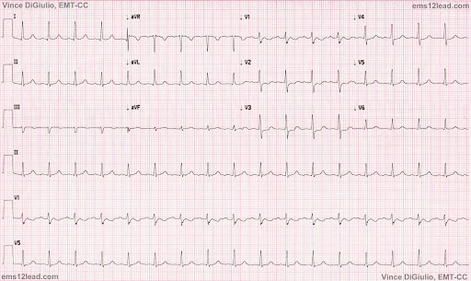
http://ems12lead.com/2015/12/26/12-rhythms-of-christmas-sinus-tach/

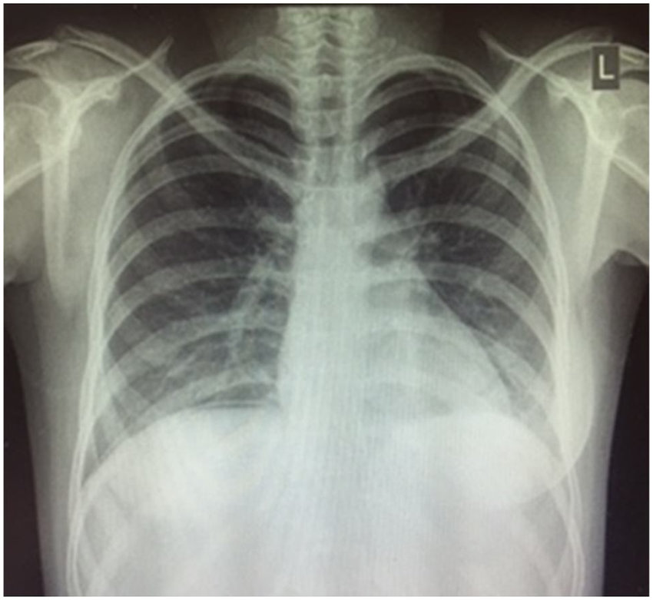
https://www.researchgate.net/figure/Erect-chest-x-ray-demonstrating-subdiaphragmatic-free-air_fig1_323084315

Appendix C: Facilitator Cheat Sheet & Debriefing Tips

Include key errors to watch for and common challenges with the case. List issues expected to be part of the debriefing discussion. Supplemental information regarding any relevant pathophysiology, guidelines, or management information that may be reviewed during debriefing should be provided for facilitators to have as a reference.

Medical Debriefing Questions
- Can someone give a summary of the case?
- What is the differential diagnosis for this patient’s specific presentation?
- What is meant by physiologically difficult airway?
- How would the case have changed if you prioritized getting a CT scan?
- What are the Surviving Sepsis guidelines? What is included in the 1hr bundle?

CRM Debriefing Questions
- Does everyone in the team feel like they knew what was going on in the case?
- How do you avoid anchoring bias?
- How do you manage diagnostic uncertainty in a critically ill patient?
- How did you feel when the patient was unable to provide you with information and was mad at you? How did you deal with that feeling?
- What do you feel went well during this case?
- What aspects of this case were challenging and how did you overcome them?
- How does everyone feel after that case?
- What can make it difficult to call for help, or a consultant, early? IE before you’ve gotten all of your investigations back?

References

1. Vakil, N. (2020). Overview of complications of peptic ulcer disease. UpToDate. Retrieved June 8, 2021, from https://www.uptodate.com/contents/overview-of-complications-of-peptic-ulcer-disease?search=perforated%20peptic%20ulcer&sectionRank=1&usage_type=default&anchor=H365487672&source=machineLearning&selectedTitle=1~108&display_rank=1#H56805017.
2. Howell MD, Davis AM. Management of Sepsis and Septic Shock. JAMA. 2017;317(8):847–848. doi:10.1001/jama.2017.0131
3. De Backer D, Dorman T. Surviving Sepsis Guidelines: A Continuous Move Toward Better Care of Patients With Sepsis. JAMA. 2017;317(8):807–808.

